Interesting to see that not all elements have to have an opening and closing tag. Elements such as img will not have to have a closing tag.

Attributes are nice to have seems like css would be best suited for all of this

#href tags need to know more on this

Cant mix up single and double quotes

Whitespace does not matter in HTML

Did not know some characters cant be used literally they need a character reference equivalent see chart below

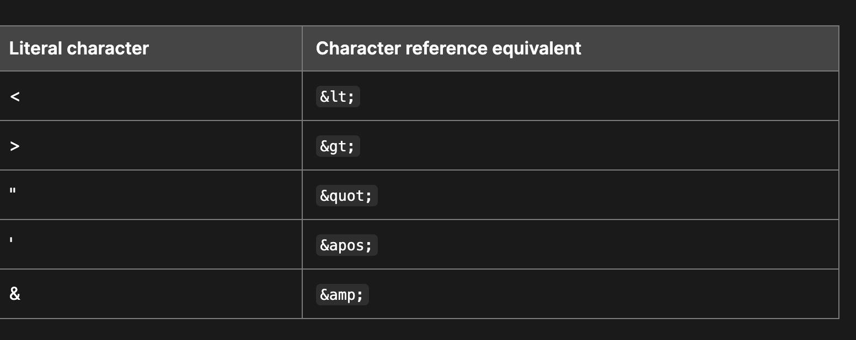

**CSS**

1. What are ways we can apply CSS to our HTML?

with an external stylesheet, with an internal stylesheet, and with inline styles.

1. Why should we avoid using inline styles?

Makes things difficult to read and maintain

1. Review the block of code below and answer the following questions:
   1. What is representing the selector? H2
   2. Which components are the CSS declarations? The code inside the brackets
   3. Which components are considered properties? Color padding

**JavaScript**

1. What data type is a sequence of text enclosed in single quote marks? String variable
2. List 4 types of JavaScript operators. Addition Subtraction, Multiplication, Assignment, Strict Equality, equals, does not equals
3. Describe a real world Problem you could solve with a Function. Finding the area of a rectangle by adding the formula as a function
4. An if statement checks a **_BOOLEAN_** and if it evaluates to **__TRUE**_, then the code block will execute.
5. What is the use of an **else if**? In the event no code evaluates to TRUE
6. List 3 different types of comparison operators.!, !==, ===
7. What is the difference between the logical operator **&&** and **||**? One reads and meaning T and T and the other one is OR meaning T or F = T but not F &F

#I would like to know more on event handlers seems like everything is an event at them moment